0000.doc




Consultation Draft Examination

Question Paper

HUMAN BIOLOGICAL SCIENCE

Time allowed for this paper
Reading/planning time before commencing work: Ten minutes
Working time for paper: Three hours

Material required/recommended for this paper

To be provided by the supervisor
This Question Paper
Standard Answer Booklet

To be provided by the candidate
Standard items: Pens, pencils, eraser or correction fluid, highlighter, ruler, printed English language dictionary and/or bilingual dictionary (non electronic and not a thesaurus)

Special Items: Calculators satisfying the conditions set by the Curriculum Council for this course.

Important note to candidates
No other items may be taken into the examination room. It is your responsibility to ensure that you do not have any unauthorised notes or other items of a non-personal nature in the examination room. If you have any unauthorised material with you, hand it to the supervisor before reading any further.

Structure of this paper

Question | Suggested Time Allocation | No. of questions parts available | No. of question parts to be attempted
Section A | 50 mins | 4 | 4
Section B | 65 mins | 4 | 4
Section C | 65 mins | 4 | 4

Instructions to candidates

1. The rules for the conduct of Curriculum Council examinations are detailed in the Student Information Handbook. Sitting this examination implies that you agree to abide by these rules.

2. Answer all questions in the Standard Answer Booklet provided. Clearly number each question as it is answered.

3. Answers may be presented in different ways provided they communicate your ideas effectively. You may choose to:
- present clearly labelled diagrams with exploratory notes
- write lists of points with sentences to link them
- produce well titled tables and graphs and/ annotated flow diagrams with appropriate introductory notes
- use some other appropriate way to present ideas.

4. You must be careful to confine your responses to the specific questions asked and to follow any instructions that are specific to a particular question.

5. Spare answer booklets are available from the examination supervisor.

The purpose of this examination is to provide each candidate with the opportunity to demonstrate his/her level of achievement of the Human Biological Science course outcomes. Some questions may provide candidates with the opportunity to demonstrate achievement at a restricted range of levels. Other questions may provide the opportunity to demonstrate achievement over the full range of levels.

THIS PAGE HAS BEEN LEFT BLANK INTENTIONALLY
Section A

This section has 4 questions. Attempt all questions.

Allow approximately 50 minutes for this section.

Question 1 will assess your achievements in relation to:

Outcome 1: Investigating and Communicating Human Biology
- your ability to analyse data, draw appropriate conclusions based on evidence and evaluate investigation plans, processes and findings
- your ability to communicate scientific understandings.

Question 1 relates to the information about Research Project A.

A scientist was investigating the effectiveness of a newly developed drug, “Neurogen”, to improve recovery from nerve cell injury. The experiment was performed as described.

Nerve cells were placed into culture medium (a solution containing nutrients to keep the cells alive and help them grow). An equal number of nerve cells (in culture medium) were transferred into nine test tubes and maintained under constant temperature and oxygen levels.
- Three of the test tubes received no further treatment.
- Three tubes received a large, single dose of Neurogen.
- Three tubes had a series of smaller doses of Neurogen added over a one week period.

After a month the growth of nerve axons in the test tubes was measured. The results are shown in the table below.

Table 1: Growth of nerve axons with different treatments of Neurogen.
TREATMENT | TUBE NUMBER | AVERAGE GROWTH OF NERVE AXONS AFTER ONE MONTH (mm)
NEUROGEN  (Large, single dose) | 1  2  3 | 0.50  0.42  0.45
NEUROGEN  (Series of small doses) | 4  5  6 | 0.80  0.98  0.90
NO TREATMENT | 7  8  9 | 0.25  0.27  0.19

1. (a) Draw an appropriate graph to represent the results in Table 1.

(b) (i) State a possible conclusion for this experiment.

(ii) What are the possible sources of error in the experiment?

(iii) How could this experiment be made more reliable?

(c) Suggest and explain further investigations that need to be done before Neurogen is approved for human use.

(d) What are the possible impacts of the findings from this research?

Question 2 will assess your achievements in relation to:

Outcome 1: Investigating and Communicating Human Biology
- your ability to develop questions and ideas to investigate and prepare an investigation plan
- your ability to communicate scientific understandings.

Question 2 relates to the information about Research Project B.

A researcher working for a pharmaceutical company had developed an adrenalin related compound (“Drug X”) which showed promise as a bronchodilator in the treatment of asthma. Bronchodilators are substances which cause the muscular walls of the airways to relax during an asthma attack thus making breathing easier. Side-effects of adrenalin-like substances are increased heart rate and blood pressure. The pharmaceutical company already has another asthma drug, Asthmat, on the market. The effectiveness of Asthmat is limited if not taken at the first signs of an asthma attack.

2. Using the above information design an investigation to compare the effectiveness of “Drug X” and Asthmat. Ensure you consider the following:
- variables
- hypothesis
- pre-testing
- a methodology to allow ethical and safe data collection
- measures to achieve reliability and reduce errors.

Question 3 will assess your achievements in relation to:

Outcome 2: Human Life and Living
- your understanding of the relationships between structure and function in the body
- your understanding of the mechanisms of life processes.

Question 3 relates to the two diagrams below about body systems.

Diagram A: Intestinal villi with blood vessels and lymph vessels.
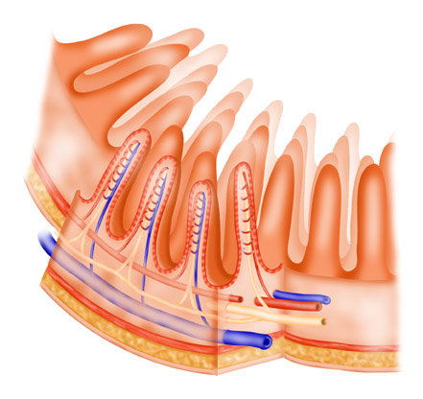
arterioles
venules
lymph vessels
intestinal villi

Diagram B: Alveoli with surrounding blood vessels.
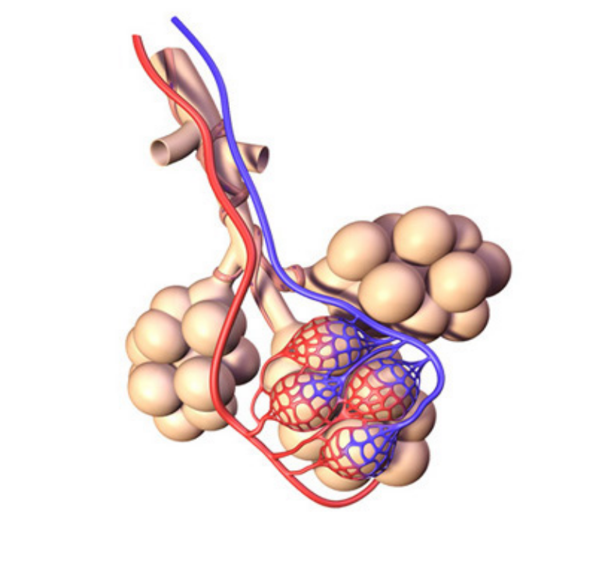
arteriole delivering deoxygenated blood to the alveoli
venules taking oxygenated blood away from the alveoli
alveoli

3. (a) The body is a collection of many different systems interacting. Their interaction allows the body to function efficiently.

      - To which body system does the structure shown in Diagram A belong?

      - What is the general function of the system to which Diagram A belongs?

      - Name three other organs in the same system as Diagram A.

      - A person’s behaviour may affect the functioning of the system, which includes the structure shown in Diagram A. Give an example of a behaviour and describe its impact on this system.

(b) Exchange of materials between the external environment and the body’s internal environment occurs at specific places in the body. Two of these places are the intestinal villi found in the small intestine (shown in Diagram A) and the alveoli in the lungs (shown in Diagram B).

For efficient exchange of materials, the exchange surfaces need to have a suitable structure.

Use Diagrams A and B to explain the features of exchange surfaces that maximise their efficiency.

(c) Describe two types of material exchange processes that occur between the internal and external environment.

Question 4 will assess your achievements in relation to:

Outcome 2: Human Life and Living
- your understanding of the relationships between structure and function in the body
- your understanding of how the body maintains balance.

Outcome 4: Human Biology and Society
- your understanding of the impact of human biology advances on individuals and society
- your understanding that attitudes and values influence the application of human biology knowledge and making informed and balanced decisions.

Question 4 relates to the article below.

This is part of an article that appeared in the West Australian Newspaper in March, 2006.

Plan to make iodine part of salt recipe

Food Standards Australia New Zealand has confirmed that .....it would decide on a proposal for all household salt to be iodised.
Research in the Medical Journal of Australia last month revealed worrying low levels of iodine in Australian children, a deficiency known to cause a range of health problems.

One of the researchers, Dr Mu Li from Sydney University’s school of public health, said the drop in iodine intake in Australia was probably due to the changes in iodine-containing sanitisers in the dairy industry and the low consumption of iodised salt.
The study of school children aged 8 - 10 in five States, including WA, found that up to 60 per cent of Australian children may have an iodine deficiency.

Iodine is found in milk and dairy products, seafood, grapes, oranges, beets and celery [as well as iodised table salt and iodine content in public water supplies].

4. (a) Iodine is an important component of the chemical structure of thyroxine, a major hormone for controlling metabolic rate. It is also essential for the growth of nerves during foetal development and infancy.

- Explain why women are advised to include fish and iodised salt in their diet when considering becoming pregnant.

- How would an iodine deficiency during embryonic and foetal development affect the health of the child?

(b) The thyroid gland is important in controlling body temperature. During a fever caused by a bacterial infection, the body’s thermostat in the hypothalamus is reset at a higher temperature.

- Use a well-labelled flow chart to explain how the body responds to the higher temperature set by the hypothalamus.

- Use this information to suggest why shivering occurs during the onset of the fever.

(c) A higher body temperature is thought to inhibit bacterial growth, however it is very important to keep the body temperature below 44-46°C.

Discuss the interaction between temperature and life processes to explain these statements.

(d) Over the past ten years, there has been a doubling of the number of children in Australia considered to be obese (more than 20 per cent over the ideal weight). During the same period, there has been a marked decrease in the number of children taking part in organised sports and a reduction in the amount of exercise children do generally.

Suggest how lifestyle choices have influenced the health of children today and how these choices may impact on their future health.

Section B

This section has 4 questions. Attempt all questions.

Allow approximately 65 minutes for this section.

Question 5 will assess your achievements in relation to:

Outcome 2: Human Life and Living
- your understanding of the relationship between structure and function in the body
- your understanding of the mechanisms of life processes
- your understanding of how the body maintains balance.

Question 5 relates to the information below about the Melbourne Commonwealth Games.

The 20 km and 50 km walk and the marathon (a 42 km run) events of the Commonwealth Games in Melbourne in March 2006 were scheduled to start in the morning at either 8 am or 9 am. The competitors had 4 hours to finish the event. Games officials took into account the expected weather conditions when scheduling these events to allow the athletes to perform in the most suitable conditions.

The expected weather conditions for Melbourne during March include a mean maximum daily temperature of 23.8ºC and an average of 10 rainy days.

5. (a) During these events, the athletes need to maintain homeostasis of the following factors:

- body temperature
- body fluid concentrations
- blood sugar
- gas concentrations.

None of these factors is maintained separately from the others.

Select two (2) of these factors to outline how the body mechanisms interact to achieve homeostasis in the athlete.

- Explain the consequences of one (1) of the following on the functioning of the athlete’s body during the event:

- high altitude training for several weeks before the Games
- drinking isotonic fluids (such as Gatorade or Staminade) instead of water during the event
- timing the Games for January when the weather is hotter and drier than in March.

THIS PAGE HAS BEEN LEFT BLANK INTENTIONALLY

Question 6 will assess your achievements in relation to:

Outcome 2: Human Life and Living
- your understanding of the relationships between structure and function in the body
- your understanding of the mechanisms of life processes
- your understanding of how the body maintains balance.

Outcome 4: Human Biology and Society
- your understanding that attitudes and values influence the application of human biology knowledge and making informed and balanced decisions.

Question 6 relates to the information below.

Infants have a series of injections immunising them against a variety of common childhood diseases. The following graph shows the changes in levels of a particular antibody from the first injection (A) and another (B) after 6 months.

Blood Antibody Levels in Response to Two Injections of Antigen

B
A
Time in months, from initial injection
Blood
Antibody
Levels

(arbitrary
units)

0
3
6
9
12

6. (a) Use the graph on page 12 to help describe and explain the cellular processes resulting from the two immunisation injections.

(b) In 1998, research findings from a study in Britain suggested an association between the measles, mumps and rubella (MMR) vaccine and autism in children. This suggested cause of autism received widespread media coverage. Since that time numerous studies from several countries involving many hundreds of thousands of children have failed to show a causal link between the MMR vaccine and autism. The latest research findings are available from community health professionals, such as local doctors and community health nurses, but this has not received the same widespread media coverage as the initial report.

Explain the impact of different sources of information on new parents in deciding on vaccinations for their child.

Questions 7 and 8 will assess your achievements in relation to:

Outcome 2: Human Life and Living
- your understanding of the relationships between structure and function in the body
- your understanding of the mechanisms of life processes.

Outcome 3: Humans and Change
- your understanding of the mechanisms of reproduction
- your understanding of the mechanisms of inheritance in humans.

Outcome 4: Human Biology and Society
- your understanding of the interactions between the advancements of human biology knowledge and the interpretation of scientific developments
- your understanding of the impact of human biology advances on individuals and society
- your understanding that attitudes and values influence the application of human biology knowledge and making informed and balanced decisions.

Question 7 relates to the illustration of a human sperm cell shown below.

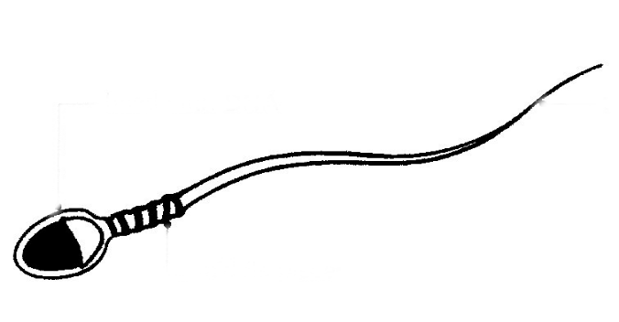

Tail
Head containing DNA
Middle piece – containing mitochondria

7. (a) What is the importance of the structure and contents of the head section to the function of the sperm cell in reproduction?

- The middle piece of the sperm cell contains several mitochondria that surround the base of the filaments that form the tail.

How are the mitochondria important in helping the sperm cell to carry out its function?

- Semen contains fructose (a type of sugar), mucus and alkaline chemicals.

Explain the function of each of these materials in increasing the chances of fertilization, should an ovum be present.

Question 8 relates to information below.

In Australian society, it is becoming increasingly common for couples to have children at a much older age than previous generations. Many first-time parents are now between 30 and 40 years of age.

8. (a) What are the pros and cons for delayed parenthood?

- One consequence of this delay in parenthood has been that older women may find it difficult to become pregnant.

  - A range of reproductive technologies is available to assist older women become pregnant. Select one of these reproductive technologies and describe the procedures involved.

  - What attitudes and values of individuals and society would influence a woman’s freedom to control her fertility?

Section C

This section has 4 questions. Attempt all questions.

Allow approximately 65 minutes for this section.

Question 9 will assess your achievements in relation to:

Outcome 3: Humans and Change
- your understanding of the mechanisms of inheritance in humans.

Outcome 4: Human Biology and Society
- your understanding that attitudes and values influence the application of human biology knowledge and making informed and balanced decisions.

Question 9 relates to the information below.

The following pedigree was drawn for a family in which individuals had an uncommon genetically determined condition that causes bone defects affecting growth and strength of bones.

The generations are identified by I, II, III, IV. The individuals with the condition are shown as black squares or circles. This condition was unknown in previous generations of this family.

I

II
Bill

III

IV

9. (a) Describe the inheritance pattern of this condition and justify your answer with evidence from the pedigree.

(b) (i) This condition is controlled by a single gene. Explain how the mutation causing this condition may have arisen.

(ii) Suggest the generation in which the mutation may have occurred. Explain the reasons for your answer.

(c) Bill met his partner at two fund raising events for promoting research into the genetic condition that he and some of her family members have.

(i) Outline how Bill and his partner could predict the chances of having an affected child.

(ii) Describe three different techniques that can reduce the chances of Bill and his partner having an affected child.

- Bill and his partner have plans for a third child. What factors are they likely to have considered in their decision to have a third child?

Question 10 will assess your achievements in relation to:

Outcome 3: Humans and Change
- your understanding of the role of reproduction and inheritance in human variability and evolution.

Question 10 relates to the table below.

Examine the table that presents data on blood groups in relation to ethnic groups.

Type | Caucasians | African Americans | Chinese | Eskimos | Australian Aborigines
O | 45% | 48% | 36% | 46% | 66%
A | 41% | 27% | 28% | 54% | 34%
B | 10% | 21% | 23% | 0% | 0%
AB | 4% | 4% | 13% | 0% | 0%

10. Given that Aborigines and Eskimos migrated into new areas from populated regions, account for the absence of B or AB blood groups in these two ethnic groups?

Question 11 will assess your achievements in relation to:

Outcome 3: Humans and Change
- your understanding of the mechanisms of reproduction
- your understanding of the mechanisms of inheritance in humans.

Outcome 4: Human Biology and Society
- your understanding that attitudes and values influence the application of human biology knowledge and making informed and balanced decisions.

11. DNA is the chemical compound that carries the inherited information between generations.

- Where in the body is DNA found?

- What is the role of DNA in a cell?

  - Two types of cell division occur in humans. The production of new stem cells uses one type. Females produce ova in the ovaries by the other type of cell division.

Describe and explain the differences between the two types of cell division and the cells that they produce.

    - Embryonic stem cells are capable of differentiating into any type of adult body cell. Theoretically, every cell in the body has the capacity to do this because they all contain the same genome. However, once a cell has differentiated and become, say, a liver cell, there is little that can be done to shift it back again. Although the adult body does contain some stem cells, they are few and scattered, difficult to isolate and give rise to only a few tissue types. Early stage embryos are a better source of stem cells and have the added advantage that they have not accumulated the mutations present in adult stem cells.

      - What ethical issues are associated with the use of embryonic stem cells?

      - Explain the significance of societal attitudes and values on stem cell research.

Question 12 will assess your achievements in relation to:

Outcome 3: Humans and Change
- your understanding of the mechanisms of reproduction
- your understanding of the mechanisms of inheritance in humans.

Outcome 4: Human Biology and Society
  - your understanding that attitudes and values influence the application of human biology knowledge and making informed and balanced decisions.

Use the information on the opposite page to answer question 12.

12. (a) Explain why the source DNA and the vector DNA are cut with the same restriction enzymes in Step 1.

(b) The chosen restriction enzymes used here produce ‘sticky ends’ to the DNA fragments. When the restriction enzymes have completed their task, ligase is added to the mixture of DNA fragments.

Explain the importance of the ‘sticky ends’ and ligase in the recombination of the DNA fragments, to produce the recombinant plasmid.

- The genetic manipulation process shown in the diagram was very controversial in the 1970’s until the successful production of human insulin in commercial quantities by recombinant DNA bacteria in 1978.

Discuss the factors that may have influenced the choice of insulin as the first application of this technology and its subsequent widespread acceptance in the treatment of diabetes from the perspective of different interested groups.

Genetic researchers can now isolate, cut out and transfer individual genes between humans and bacteria for applications such as making human products like insulin and human growth hormone. The process is shown in the diagram below.

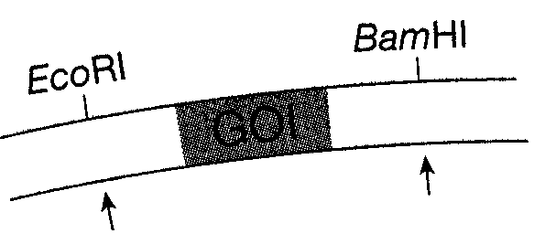
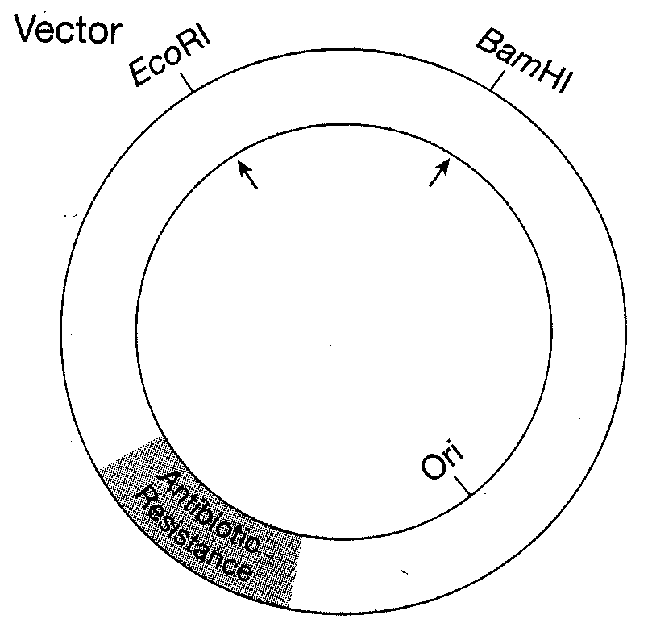
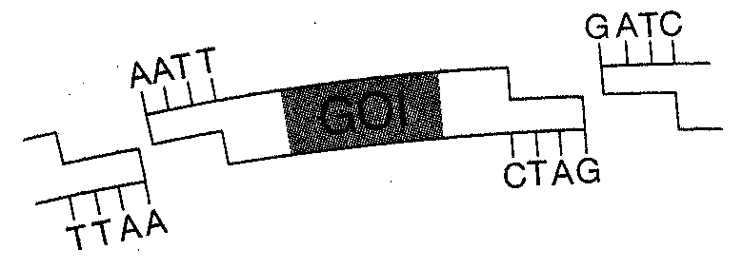
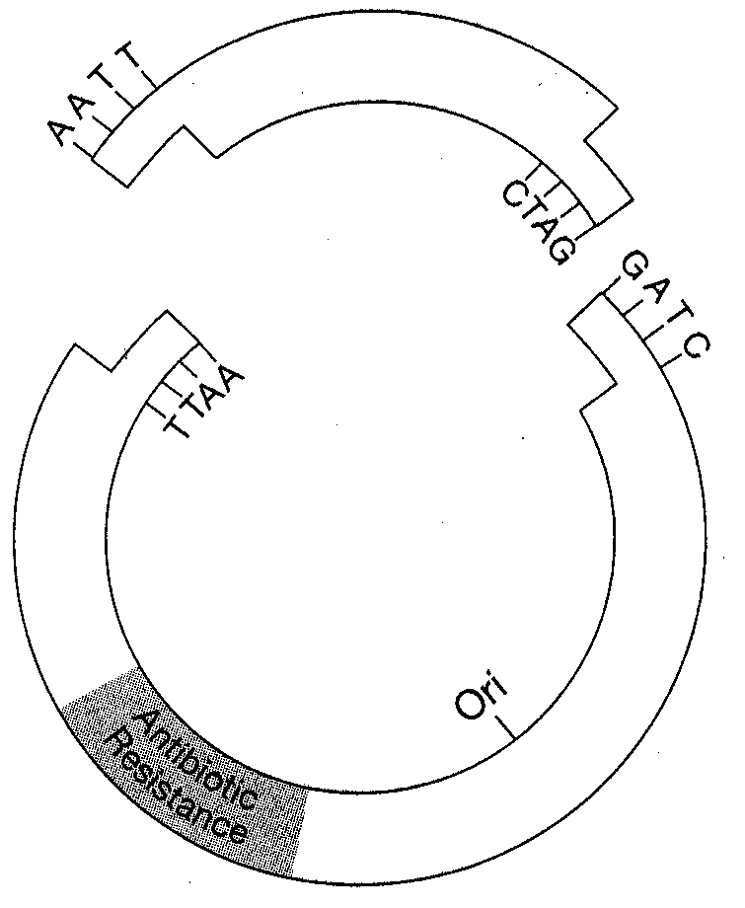
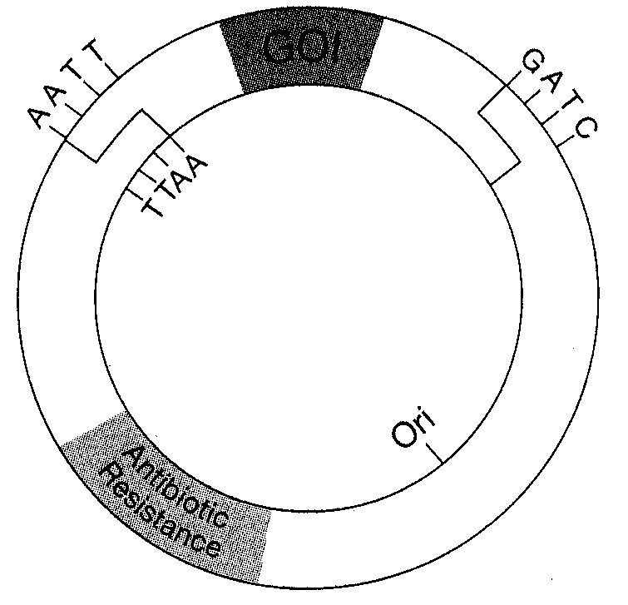
1
2
2
3
Source DNA
Sticky ends
GOI and vector DNA fragments are mixed together with DNA ligase to produce the recombinant plasmid.
This fragment is discarded and replaced with the DNA fragment containing the GOI.
Vector DNA
1
Gene of Interest (GOI)

END OF QUESTIONS
Check that you have written your Student Number on the front cover of the
Standard Answer Booklet

ACKNOWLEDGEMENTS

Question 3: Diagram A
Living-Art. (2003). Small intestine wall. Retrieved April, 2006, from http://www.livingart.org.uk/new/medical/small%20intestine%20wall.htm.

Diagram B
3D Science.com. (n.d.). Alveoli with branching bronchiole. Retrieved April, 2006, from http://3dscience.com/bronchiole_branching_into_alveoli.asp.

Question 4: Plan to make iodine part of salt recipe. (2006, March 16). The West Australian, p. 3.

Question 9: Table from: Sanson, P., & Pears, F. (Eds). Biology two: Activity manual. Port Melbourne, Vic.: Heinemann, p. 187 [Table 3].

Question 12: Diagram from: Micklos, D., Freyer, G.A., & Crottey, D.A. (2003). DNA science: A first course (2nd ed.). Cold Spring Harbor, NY: Cold Spring Harbor Laboratory Press, p. 123.

Published by the Curriculum Council of Western Australia
27 Walters Drive
OSBORNE PARK WA 6017

